Nepal College of information Technology
Imadol lalitpur
Unit Test Fall Semester 2006/2007

Program : BE-IT/CE Semester: I
Time : 2hrs Year : III

FM 60 PM 30

DSP/SSP

1. Explain the working principle of D.S.P. with necessary block diagram. Also mention the advantage & disadvantage of digital signal processing over analog signal processing. (For DSP) 10
1. a) Determine the Fourier transforms of the rectangular pulse signal defined as (For SSP) 7

x(t)=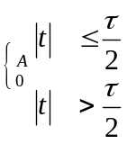
b) What are the conditions for the existence of the Fourier series and Fourier transform of the analog signal. (For SSP) 3
2. a) Final the Nyquist rate and Nyquist interval for the signal x(t)=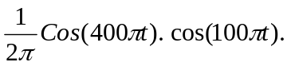 6
b) What is aliasing and what are the corrective measures of the aliasing effects. 4
3. Check for linearity causality, time invariant and stability properties of the signals. 10
i) y(n) = e^{x(n)}
ii) y(n) = n x (n)

4. The impulse response of the LTT system is 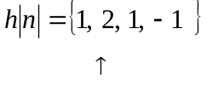
Determine the response of the system to the i/p signal 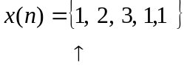
5. Determine the total solution of the difference equations y(n)=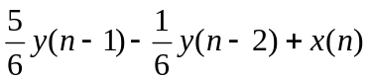 10
6. Determine the z-transform of the sequence 10
